|  |  |  |
| --- | --- | --- |
| **CL-1002 Programming Fundamentals** | **LAB - 06**  **Iterative Loops and 1D Arrays**  **in C** | |
| **NATIONAL UNIVERSITY OF COMPUTER AND EMERGING SCIENCES**  **Fall 2023** | |  |

**EXERCISE**

**QUESTION# 01**

Write a C Program that takes any number from the user and identifies if the number is a perfect number or not.

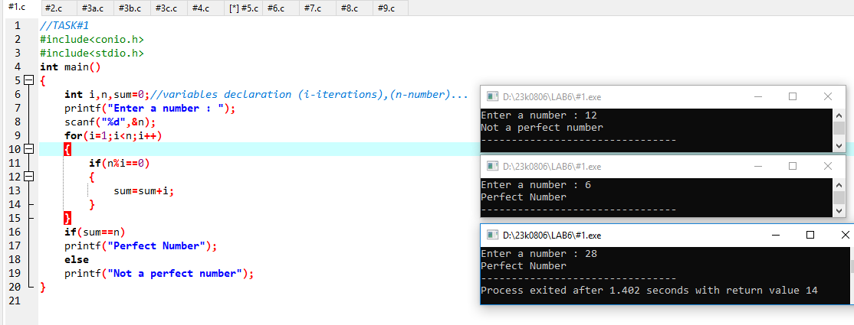

**QUESTION# 02**

Write a program that will generate the Fibonacci series up to 10000. Also find the sum of the generated Fibonacci numbers divisible by 3, 5 or 7 only.

**An example of the Fibonacci series is:** 1 1 2 3 5 8 13 25..........

**Note:** Do this task by using a ***for loop*** **DO NOT** use arrays for this.

**QUESTION# 03**

Using Loop display these patterns.

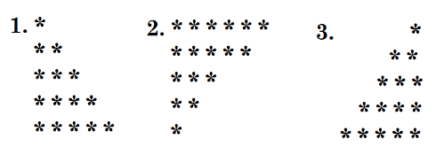

**QUESTION# 04**

Consider Two integers a and b taken as input from the user. Using Loops iterate the value of a till the value of b.

If the value of a<=9 the output should correspond to the English representation of the

numbers i.e., 8=Eight, 9=Nine etc.

If the iteration exceeds 9 then the programs should print if the exceeded number is even or odd.

**Example:**

Input= 8,11

Output= Eight, Nine, Even, Odd

**QUESTION# 05**

Write a C program that produces the following output:

0 0 0 0

1 1

2 2 2 2

3 3

4 4 4 4

5 5

6 6 6 6

**Note:** Only use single loops **(No Nested Loops)**

**QUESTION# 06**

Write a program for a match-stick game between the computer and a user. Your program should ensure that the computer always wins. Rules for the game are as follows:

* + - 1. There are 21 matchsticks.
      2. The computer asks the player to pick 1,2,3 or 4 match sticks.
      3. After the person picks, the computer does its picking.
      4. Whoever is forced to pick up the last matchstick loses the game.

**QUESTION# 07**

Write a C Program that takes a user input array and prints the sum of its elements.

**Input:** {1,2,3,4,5,6,7,8,9}

**Output:** 45

**QUESTION# 08**

Write a program in C to read n number of values in an array and display it in reverse order.

**Input:** {1,2,3,4,5,6,7,8,9}

**Output:** 9 8 7 6 5 4 3 2 1

**QUESTION# 09**

Write a C Program to find the minimum and maximum number in an array.

**Input:** {4,1,6,8,10,21,8,9,2,6}  
**Output:**

Minimum Number = 1

Maximum Number = 21